**Analysis Report**

Student : Priyanka Prasanna Kumari

Student ID# : 301377064

**Question#1:**

**Unique Digits:**

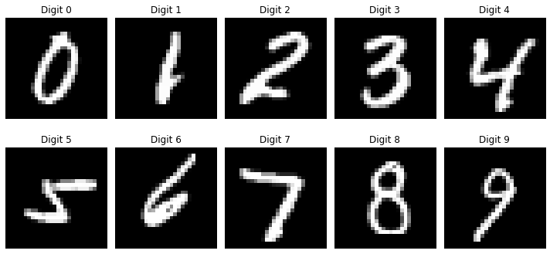

**Variance ratio:**

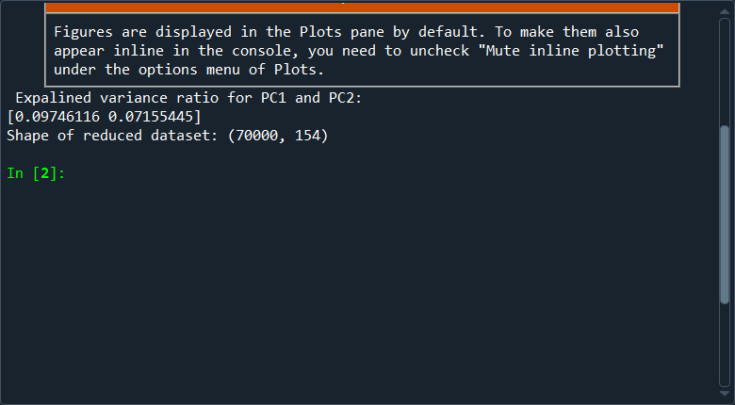

**Principal component projection:**

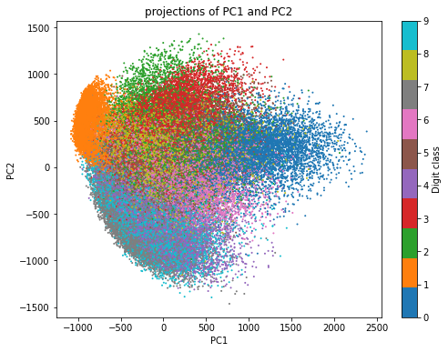

**Original and compressed digits:**

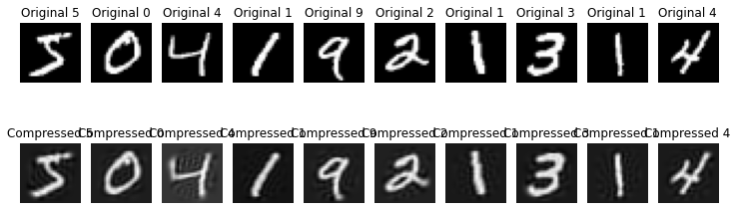

**Question#2  
Swill Roll Dataset**

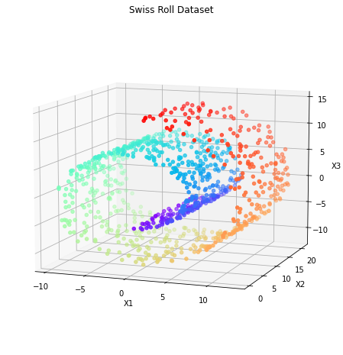

**kPCA results [linear kernel , a RBF kernel , sigmoid kernel ]**

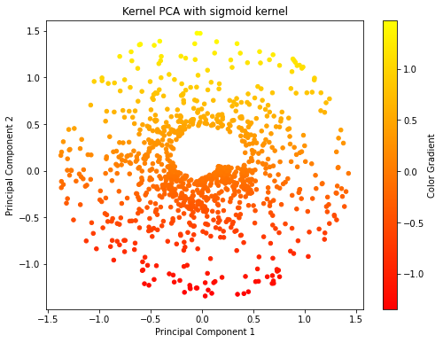

**Kernal PCA with different Kernals[linear,rbf,** **sigmoid]:**

**Linear Kernal :** Will produce result similar to traditional PCA. Data is projected linearly**.**

**RBF kernel:** Used for non – linear data set , reveals clearer separation between different parts of the dataset.

**Sigmoid kernel**: Used as another non -linear approach . The separation between the layers of the roll might not be as clean as with the RBF kernel.

**Observation** : The RBF kernel provides a meaningful representation for the non-linear swiss roll data, as it effectively captures the curved structure and unfolds it in a 2D space. The linear kernel struggles with this non-linear structure, leading to less separation in the 2D projection. Finally, the sigmoid kernel might offer some level of separation, but its performance will depend on the dataset and chosen hyperparameters.

***GridSearchCV*  with rbf kernal:**

**Result plotted from GridSearchCV:**

**Conclusion :**

* Kernel PCA with an RBF kernel and a gamma of 0.1 was able to extract meaningful features from the non-linear Swiss Roll dataset and project it into a lower-dimensional space where the data became more separable.
* Logistic regression was then able to classify the data with 71% accuracy based on this reduced feature set.